Student Learning Outcomes Reports:

Instructions for Preparing the Annual Report with Examples

Last Updated July 2022

Student Learning Outcomes Reports:

Instructions for Preparing the Annual Report

with Examples

To respond to changing expectations of the University’s accreditor, SACSCOC, Carolina revised the template to be used for Student Learning Outcomes Reports submitted after July 1, 2022. The new form can be downloaded here.
These changes are relatively small and are simply designed to elicit additional details on:
- How the assessments were carried out
- The results of the assessments
- Strengths and weaknesses observed in student performance that might inform improvements
Most importantly, the new form emphasizes SACSCOC’s requirements that reports provide evidence of continuously seeking improvement in student learning, even if the program is meeting its performance goals.
All programs must use the new form to report assessment results for academic year 2021-22. Those who need to submit prior year reports should use this form as well.
These instructions and examples have been updated for the 2021-22 reporting cycle. Included are descriptions of what should be reported in each section of the new report, along with examples of undergraduate and graduate reports and rubrics that were used.
To learn more about assessment for academic programs, please visit Academic Program Assessment.

Please contact Dr. Bryant Hutson in Institutional Research & Assessment for assistance with any part of the Student Learning Outcomes Report requirements.

INSTRUCTIONS
Student Learning Outcomes Report
For Academic Year:

School: |  | Department:
Degree/Major: |  | Contact:

Part 1: Assessment Plan
Attach the assessment plan that was in effect in the year covered by this report.

Part 2: Report on Student Learning Outcomes Assessed for This Year: Methods, Findings, and Improvements Made or Planned in Response to Results
Instructions: For each student learning outcome assessed this year, copy the outcome statement from the assessment plan, and then describe the methods, measures, targets, results, and improvements or action plans made based on the findings. To add
more outcomes, copy and paste the outline as needed.

- Student Learning Outcome Assessed: (copy outcomes statement from assessment plan and paste here)

Methods/Measures Used to Assess Achievement of This Learning Outcome (Note: If multiple measures were used to assess this outcome, please copy and answer these questions for each.)

What types of student work were evaluated?

Report on direct methods/measures of learning such as course assignments, research papers, projects, portfolios, artistic or creative performances; comprehensive exams; thesis/dissertation proposals, practicum performance, etc. See the Methods of Assessing Program Level Learning Outcomes guide for other examples. Indirect measures such as student surveys, grade point averages, course evaluations, etc., can be reported only to supplement direct measures in the annual report.

What dimensions of the student work were measured to assess student achievement of this learning outcome? How was the work scored, graded, rated, or analyzed and by whom? Attach rubrics or other rating instrument used.

Examples:
      - “A faculty review team used a rubric with 3-point scale (Excellent, Acceptable, Unacceptable) to rate a sample of papers collected from the XXXX 698 capstone course over the past two years on each of the following dimensions: knowledge of the discipline, research methods, writing quality, analysis, and conclusions. Scores on each dimension were averaged across raters.”
      - “The doctoral comprehensive exam consists of sets of questions measuring: (1) foundational knowledge of the discipline, (2) research methodology, and (3) expertise in a concentration area. Faculty committee members graded these sections separately on a four-point scale (High Pass, Pass, Low Pass, Unacceptable).”
    - “The STAT 600 instructor summarized performance on final exam responses to 10 multiple choice questions to test knowledge of statistical terminology and an essay question asking students to critique analytical approaches reported in a research article. Essays were graded on a 3-point scale based on the following criteria: recognition of the fit between the methods and research question, identification of the limitations, and recommendations for improving the study.”

Performance Target for Assessment Results: What percentage of students assessed should achieve the outcome, or, what other benchmark did the program use to define success?

Defined as the level of success that faculty have identified as acceptable for the program. Typically expressed as the percentage of students who achieved a specific score or grade; can also be a group mean or a benchmark or even a qualitative description depending on how the learning outcome was measured.

Examples:
      - “At least 90% of students will score 70 or higher on the final exam.”
      - “The mean practicum supervisor rating on each of the six criteria on the rubric will be 4.0 or higher on a 5.0 scale."
      - “80% of students taking the comprehensive exam for the first time will receive a High Pass or Pass rating from the committee on each section.”

Results from This Assessment with Analysis and Interpretation:

How many students or work products were assessed and how many achieved the intended outcome?

Estimate if necessary.

Summarize the results from the analysis of data collected. Include tables and graphs for quantitative data if feasible and descriptions of qualitative findings.

Be sure to interpret the findings for your readers.

- What relative strengths and weaknesses in student performance were identified through this assessment? To what do you attribute those results?
In what areas did students perform particularly well? Did those performances appear to reflect, for example, good preparation in prerequisite courses, the program’s emphasis on early research experiences, etc.? In what specific areas did the faculty observe somewhat lower performances compared to other areas of the assessment? What might that suggest?

Actions Taken or Planned to Improve, Enhance, or Sustain Student Success in Achieving This Learning Outcome: If performance target was not met, identify improvements initiated. If performance target was met or exceeded, describe efforts the program has made to further enhance or sustain student success related to this outcome.

If the performance target was not met across all parts of the assessment, describe improvements made to date or action plans the faculty decided to carry out to address these findings.
Examples:
  - “To improve students’ skills in orally communicating the results of their projects, we implemented a requirement for all students to attend our annual workshop on best practices in research presentations and to submit a video for a critique and coaching session with a faculty expert.”
  - “To ensure that students have the coding skills they will need for success in upper-level quantitative courses, the faculty decided to add a lab to the introductory statistics course.”

If the performance target was met, avoid stating repeatedly that “no improvement is needed” or “will continue to monitor.” The University’s accreditor, SACSCOC, requires programs to “…provide evidence of seeking improvement.” Given these continuous quality improvement expectations, please give examples of what the program has done in the past year to further enhance or sustain student achievement of this learning outcome.
Examples:
- “While we achieved our overall performance target on this outcome based on this year’s results, we modified our undergraduate capstone course to include a mid-term check-in with the lead instructor to provide the research teams with an opportunity for early feedback.”
- “All students performed at very high levels on each of the criteria for the dissertation and defense this year, but the faculty decided to require future candidates to present their work in progress at our graduate seminar to gain additional practice responding to audience questions.”
- “Student learning in core classes continues to be validated by their performance on the foundational knowledge section of the written comprehensive examination. However, anecdotal evidence suggests that grading and other teaching assistant activities may be extending their time to degree. We have decided to interview a sample of students about their workloads and determine if adjustments might be needed.”

Part 3: Follow-Up on Prior Year Improvements Reported and Action Plans -- REQUIRED
Review your prior year assessment reports and provide updates on improvements the program reported that it had initiated and/or actions the faculty decided to take based on assessment results in those years.
- What did the program attempt to improve and what actions did the faculty decide to take?
- What have you observed to date about the effectiveness of those improvement efforts?

Examples:
- “In our 2018 report, we described our goals to enhance student preparation for research. We created the Graduate Research Group (GRG) in 2020 to serve as a bi-monthly research forum with presentations by faculty and graduate students. The GRG is now providing students with (1) development of the language to understand and exposure to various perspectives of research in this discipline, (2) an opportunity to see what work-in-progress looks like, since they typically read peer-reviewed, finalized research, (3) a perspective on long-form presentations in preparation for the job market. Moreover, the GRG has been quite successful in building community in interdisciplinary research and within our department. We have observed that the percentage of students who co-author publications with faculty and are accepted to present their work at major conferences has grown each of the past two years.”

- “A number of changes and improvements have been made to better support our students’ success and progress toward their degrees based the findings in our 2017-18 and 2018-19 assessment reports. These have included the development of student workshops on writing and comprehensive exams, the creation of a brown bag series for students to share their ongoing research and challenges, and a peer-mentoring program for existing and incoming students. These were well received by students and it is our observation that they are more confident in approaching the exams and seem to move forward more quickly in preparing their proposals.

- “In our 2017-18 assessment report, the department emphasized the importance of publications for students’ success in the academic job market and decided to try to increase the number and percentage of graduates reporting them on their CVs prior to graduation. With the goal of building stronger job candidates, the department provided a publication workshop, and directors focused on assisting students with turning dissertation and coursework into publications. The fact that 80% of graduates in the last two years (up from 68%) have had at least one peer-reviewed publication upon completion is in part a reflection of our attention to this”.

UNDERGRADUATE PROGRAM EXAMPLE
Student Learning Outcomes Report
For Academic Year:
2016-17

School: | College of Arts & Sciences | Department: | Archaeology
Degree/Major: | BA in Archaeology | Contact:

Part 1: Assessment Plan
Attach the assessment plan that was in effect in the year covered by this report.

Part 2: Report on Student Learning Outcomes Assessed This Year: Methods, Findings, and Improvements Made or Planned in Response to Results
Instructions: For each student learning outcome assessed this year, copy the statement from the assessment plan, and then describe
the methods, performance targets, findings, and improvements or action plans made based on the findings. To add more outcomes, copy and paste the outline as needed.

- Student Learning Outcome Assessed: Students will demonstrate the ability to recover and document a variety of forms of material culture and archaeological contexts.

Methods/Measures Used to Assess Student Achievement of This Learning Outcome
- What types of student work were evaluated? Archaeology majors’ and minors’ papers from the following laboratory methods courses have been retained for this purpose and were evaluated by a committee of Curriculum faculty using the rubric attached at the end of this report:
    - Archaeobotany
    - Laboratory Methods: Human Osteology
    - Laboratory Methods: Zooarchaeology
    - Laboratory Methods: Ceramic Analysis
- What dimensions of the student work were measured to assess student achievement of this learning outcome? How was the work scored, graded, rated, or analyzed and by whom? Attach rubrics or other rating instruments. A faculty committee reviewed 24 papers and projects collected between 2012 and 2016. These were then scored using a faculty-developed rubric developed to examine the students’ (1) command of archaeological principles, (2) ability to work with data, and (3) expository skills. See Appendix for copy of the rubric.

- Performance Target(s) for Assessment Results: For each of the dimensions rated, 70% of students will score at a 4 or higher on a scale of 1-5 with 1=Poor and 5=Excellent.

Results from This Assessment with Analysis and Interpretation:

Report number of students assessed and number who achieved the intended outcome. See above.

Summarize quantitative findings in tables or graphs if possible and qualitative results in a narrative. The scores are summarized in Figure 1. The summary statistics for the student scores are provided in Table 1. Student scores on data analysis and data interpretation are marginally lower than concepts, the area where students scored the highest. When the subcategories are merged, the differences among Principles, Data, and Exposition become clearer. The average scores on Principles and Exposition are higher than for Data.

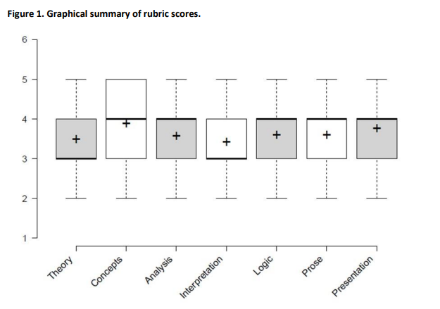

Table 1 Summary statistics of paper scores

 |  | Mean | SD | Mode | Median
Principles | Theory | 3.5 | 1.47 | 3 | 3
 | Concepts | 3.8 | 0.88 | 3 | 4
Data | Analysis | 3.5 | 0.86 | 4 | 4
 | Interpretation | 3.4 | 0.75 | 3 | 3
Exposition | Logic | 3.6 | 1.06 | 4 | 4
 | Prose | 3.6 | 0.95 | 4 | 4
 | Presentation | 3.7 | 1.14 | 4 | 4

When using the scores received by each student for each measure as categorical variables, this difference is not statistically significant (chi-square = 11.5, df = 6, p = 0.074), but does suggest some tendencies. Students seem to be marginally more effective at conveying conceptual knowledge than at applying those concepts to analyses and interpretations of archaeological data. In Bloom’s taxonomy of learning, remembering and understanding are one level of learning, while applying and analyzing represent another level of comprehension.

One reason that the Archaeology major requires courses in archaeological practice is that students generally have few opportunities during their other coursework to produce work at the application/analysis level of learning. These courses represent a vital contribution to our curriculum and to the general education of our majors.
- What relative strengths and weaknesses in student performance were identified through this assessment? To what do you attribute those results? The Archaeology Curriculum provides a breadth of courses for students. Some emphasize conceptual or abstract learning, others offer more hands-on opportunities. The results of this assessment indicate the continued importance of offerings such as the archaeological practice courses. In particular, it is noted that students scored highly (median and modal scores of 4/5) in the development of technical data analysis skills. Development of technical competence in the identification of archaeological materials is a concrete benefit that serves students well as they move forward in their career and educational paths. Lab courses are therefore a valuable component of the course offering under the Archaeology degree program.

Lower scores and higher standard deviations were observed in the area of Theory in lab reports. This suggests that instructors need to help students better understand the connections between the theory that structures the interpretation of data and the data themselves.

We note that in an earlier assessment (2013), an evaluation of student work indicated the need for improvement in the area of Exposition. Subsequently, faculty in the Curriculum have offered workshops to raise the level of student performance in this area, which seems to be reflected in the relatively strong scores for that category in this corpus of student work.

Actions Taken or Planned to Improve, Enhance, or Sustain Student Success in Achieving This Learning Outcome: Based on these findings, the faculty decided to:
- Engage faculty in identifying ways that analytical and application skills can be developed and reinforced in settings besides archaeological practice courses.
- Structure research projects in Lab Methods courses so that students receive feedback from instructors on an initial draft of their manuscripts and allowing them to revise and resubmit. This method would allow instructors to identify student weaknesses in connecting Theory and Concepts to Data Analysis and Interpretation (where scores were lowest) and explicitly help students bridge the gap between these two types of learning processes.
- Continue to emphasize the importance of Exposition and offer opportunities including workshops for students to build strength in the technical writing.

Part 3: Follow-Ups on Prior Year Improvements and Action Plans Reported -- REQUIRED
Review your prior year assessment reports and provide updates on improvements the program reported that it had initiated and/or actions the faculty decided to take based on assessment results in those years.
- What did the program attempt to improve and what actions did the faculty decide to take?
- What have you observed to date about the effectiveness of those improvement efforts?

Over the past five years, our learning outcome assessments have suggested that we could improve the skills we give to our students in preparing papers. We addressed that specifically by offering workshops teaching them how to create papers whose illustrations and general appearance meet professional standards. These workshops were aimed at students writing honors theses, but other students elected to take these workshops as well. The participation and positive feedback we have received have supported our decision to offer these workshops.

Student responses to our survey of seniors described in the 2014-15 assessment report indicated that somewhat lower levels of satisfaction were registered for the variety of archaeology courses and lower division course offered. We responded to that with plans to expand and improve the course offerings that satisfy the requirements of the major and minor. As a result, we added courses to the Undergraduate
Catalog for Fall 2015 which satisfied the “Topics in Archaeology” requirement, including ANTH 149, 651; LING 558, 560, and 561. 2015-16 was the first year that LING courses were included in our repertoire.

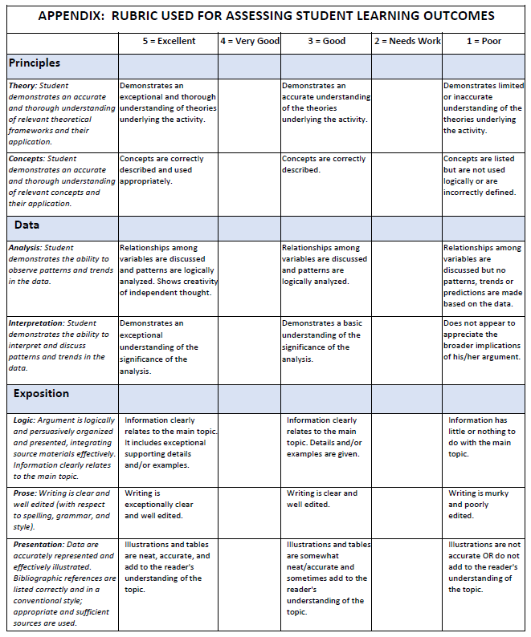

GRADUATE PROGRAM EXAMPLE
Student Learning Outcomes Report
for 2019-20

School: | College of Arts & Sciences | Department: | Interdisciplinary Studies*
Degree/Major: | MA in Interdisciplinary Studies* | Contact:
*Department and degree program do not exist at UNC-Chapel Hill. This report was constructed for illustrative purposes only.

Part 1: Assessment Plan
The Assessment Plan that was in effect for the year covered by this report is attached.

Part 2: Report on Student Learning Outcomes Assessed: Methods, Findings, and Improvements Made or Planned in Response to Results
Instructions: For each student learning outcome assessed this year, copy the outcome statement from the assessment plan, and then describe the methods, performance targets, results, and improvements or action plans made based on the findings.

Student Learning Outcome Assessed: Discuss and critically assess contemporary and historically important theories and concepts in the discipline.

Methods/Measures That Were Used to Assess Student Achievement of This Outcome
- What types of student work were evaluated? We assess mastery of foundational knowledge and disciplinary theory by performance on the required comprehensive exam substitute, an extended bibliographic essay (15-20 pages). This exercise requires students to reflect upon and consolidate what they have learned in their first-year courses and to focus their emerging interests and thesis research in the discipline.
- What dimensions of the student work were evaluated to assess student achievement of this learning outcome? How was the work scored, graded, or rated and by whom? Attach rubrics or other rating instrument used. The essay is evaluated by students’ thesis committees as High Pass, Pass, Low Pass, and Unacceptable based on their ability to: (1) Outline historical and intellectual connections among issues and ideas that have influenced the student’s own developing interests and research trajectory, and (2) frame those issues within an interdisciplinary context. Results are aggregated and reviewed by the faculty at its annual retreat.

Performance Target(s) for Each Assessment Method Used: 80% pass rate defined as all committee members rating the essay as High Pass or Pass based on achievement of the two major expectations outlined above.

Results from This Assessment with Analysis and Interpretation:

Report number of students assessed and number who achieved the intended outcome. Summarize quantitative findings in tables or graphs if possible and qualitative results in a narrative. Four of the five (80%) students expected to undertake the literature review this year were judged by faculty as having completed the exercise successfully. One student was asked to retake two of the questions.
What relative strengths and areas for improvement in student performance were identified through this assessment? To what do you attribute those results? Students demonstrated a thoughtful ability to pull together key texts and concepts from their coursework to address disciplinary arguments central to their MA thesis research topics and intended career paths. This suggests that the current degree plan requiring two courses in interdisciplinary theory and methodology and six electives, is providing students a solid common foundation and opportunities to delve deeply into an area of specialization. The student who retook a portion of the exam had requested to sit for the exam a semester early, perhaps cutting their preparation short. She successfully completed the exam the following semester.

Actions Taken or Planned to Improve, Enhance, or Sustain Student Success in Achieving This Learning Outcome:
Although the target was met, the faculty decided to share actual exemplary essays from prior years with first-year students to help them become familiar with the depth and breadth of topics that the exam covers.

Student Learning Outcome Assessed: Demonstrate the ability to think creatively and critically in approaching specific interdisciplinary research topics.

Methods That Were Used to Assess Student Achievement of This Outcome at the Program Level
- What types of student work were evaluated? We assess the students’ ability to complete high quality research within the discipline by their completion of a well- researched and well-argued MA thesis that requires a text roughly the length of an article for a scholarly journal, 45-60 pages. It is actually more difficult for students at this level to condense their work into an article-length piece than to construct the traditional longer, more loosely-argued thesis, but makes it easier for them to revise for publication.
- What dimensions of the student work were evaluated to assess student achievement of this learning outcome? How was the work scored, graded, or rated and by whom? Attach rubrics or other rating instrument used. The thesis judged by individual thesis committee members as High Pass, Pass, or Unacceptable based on a holistic evaluation of students’ critical thinking in framing the research topic, the quality of their research skills, and the appropriateness of methodology used to address the question and data collected. Results are aggregated and reviewed by the faculty at its annual retreat.

Performance Target(s) for Each Assessment Method Used: 80% pass rate, with passing defined as all committee members rating the overall essay as High Pass or Pass.

Results from This Assessment with Analysis and Interpretation:

- Report number of students assessed and number who achieved the intended outcome. Summarize quantitative findings in tables or graphs if possible and qualitative results in a narrative. The theses of 7 of the 8 (88%) students this year were judged to be at the High Pass level overall. The eighth student is expected to complete the thesis next year. The performance target was met.
- What relative strengths and weaknesses in student performance were identified through this assessment? To what do you attribute those results? All students demonstrated exceptional performance in framing important thesis topics relevant to their career interests and in their selection and application of research methods. The preparation students are receiving from the required core course in qualitative research methods contributes to these good results.

Actions Taken or Planned to Improve, Enhance, or Sustain Student Success in Achieving This Learning Outcome:

We are very pleased with the quality of the master’s theses that our students are producing and are actively encouraging students to prepare their thesis papers for publication.

Student Learning Outcome Assessed: Demonstrate facility with appropriate methods for dissemination of knowledge in their area of specialization.

Methods That Were Used to Assess Student Achievement of This Outcome at the Program Level
- What types of student work were evaluated? We assess students’ facility in sharing knowledge by evaluating the quality of their MA thesis research presentations at our year-end Colloquium and by national conference presentations.
- What dimensions of the student work were evaluated to assess student achievement of this learning outcome? How was the work scored, graded, or rated and by whom? Attach rubrics or other rating instrument used. Faculty and student Colloquium attendees rated each presentation using a Qualtrics faculty-designed rubric to evaluate six dimensions of research presentation quality (see table below) on a scale of 1-4 with 1=Poor, 2=Fair, 3=Good, 4=Outstanding.

Performance Target(s) for Each Assessment Method Used: On each dimension, 70% of presentations will receive a rating of 3 or 4.

Results from This Assessment with Analysis and Interpretation:

- Report number of students assessed and number who achieved the intended outcome. Summarize quantitative findings in tables or graphs if possible and qualitative results in a narrative. Eight students working on theses this year presented their work and received ratings. The distribution of results across performance dimensions are provided below:

Colloquium Research Presentation Ratings (N=8)
 | Poor=1 |  | Fair=2 |  | Good=3 |  | Outstanding=4 |  | % Rated as 3 or 4 | Mean
 | N | % | N | % | N | % | N | %
Overall Organization | 0 | 0.0% | 1 | 12.5% | 4 | 50.0% | 3 | 37.5% | 87.5% | 3.3
Significance of the Research | 0 | 0.0% | 2 | 25.0% | 5 | 62.5% | 1 | 12.5% | 75.0% | 2.9
Explanation of Methodology | 1 | 12.5% | 2 | 25.0% | 3 | 37.5% | 2 | 25.0% | 62.5% | 2.8
Results (graphs, tables, etc.) | 1 | 12.5% | 2 | 25.0% | 3 | 37.5% | 2 | 25.0% | 62.5% | 2.8
Conclusions and Implications | 1 | 12.5% | 1 | 12.5% | 4 | 50.0% | 2 | 25.0% | 75.0% | 2.9
Engagement with Audience | 2 | 25.0% | 3 | 37.5% | 3 | 37.5% | 0 | 0.0% | 37.5% | 2.1
Lack of funding kept all but one graduating student from presenting at national conferences this year. One student did, however, produce a video connected to her thesis research and screen it locally.

What relative strengths and areas for improvement were identified through this assessment? To what do you attribute those results? The presentation ratings were somewhat uneven. The target was exceeded on 3 of the 6 dimensions – Overall Organization, Significance of the Research, and Conclusions and Implications. Performances fell below the 70% mark for Methodology and Results with the lowest ratings related to Engagement with Audience (37.5%). Some students rushed through their presentations and gave unclear answers to questions about methodology. For many, the colloquium was their first formal presentation of this kind.

Actions Taken or Planned to Improve, Enhance, or Sustain Student Success in Achieving This Learning Outcome: The faculty decided to require student presentations in all core courses and the data visualization short course offered by UNC Libraries’ Research Hub. In addition, our chair has been active in development work to raise funds for student professional development to defray the cost of travel to give all students opportunities to present their work at conferences.

Part 3: Follow-Up on Prior Year Improvements Reported and Action Plans REQUIRED
Review your prior year assessment reports and provide updates on improvements the program reported that it had initiated and/or plans for improvement the faculty decided to make based on assessment results in those years.
- What improvement efforts did the faculty undertake?
- What have you observed to date about the effectiveness of those improvement efforts?

O
The results from the alumni survey that we reported in last year’s assessment report indicated that students wanted more practical links to future employers and support in job search strategies. We responded by sponsoring a panel presentation by local professionals currently working in the public sector in North Carolina. Based on feedback received, students found this very valuable as they considered career path options with this degree.

4: Other Continuous Improvement Efforts Related to This Program

